**THE ELECTRIC FLING**

BACKGROUND

In spite of the lead researcher’s protests, a couple of journalists were permitted to come to the asteroid to create a radio documentary covering the research project while it was still active. Strict rules were enforced, forbidding the journalists from leaving the steroid for the project’s duration. When the project was shuttered, the lead researcher demanded all recordings be seized and brought to her, ensuring no unapproved (read: unsavory) information might be leaked. However, they ended up scattered around the research site … almost as if by intention.

For the past 5 years, journalist Roscoe Clanton has been trapped at the research site’s last safe haven, the local tavern. Heartsick from the loss of his former assistant and romantic interest, Roscoe asks the player to help him get back at those responsible for his loss so he might finally escape this place once and for all. He implores the player to recover the audio log interviews he conducted with the lead researcher, intending to use them as leverage against the research company to buy his way out of here. Little does Roscoe know, the recordings hold key answers to his past, as well as his future.

GOALS

* Utilize existing, ancillary characters to make the world and quest feel more believable/alive.
* Further draw the player’s attention to and reward them for engaging with our new audio log feature.
* Reward exploration of the research site and its various facilities.
* Provide the player heavy agency in progress and completion without the complexity a double-cross option would introduce.
* Provide a quest that relieves some of the crit path tension while exploring the project’s repercussions on a more personal level.

PREMISE

Stranded by the company whose research project he was tasked with reporting, **Roscoe**’s looking for a way out of here. He asks the player to retrieve a special subset of recordings for him–in part, hoping he might use them as leverage to get off the asteroid (the research company wouldn't want the journalists' observations of the project getting out), but also to preserve the last work he completed with his former assistant and believed-to-be-dead romantic interest, Georgie.

Roscoe will reveal the location of 4 audio logs – 4 revealing recordings from his interviews with the lead researcher. Knowing the company will accept no less, he tells the player he’ll need all 4 logs if he has any chance of negotiating his passage off-world.

However as the player collects the logs, they will stumble upon one that has been replaced with an audio log from Roscoe's former assistant, Georgie. On her log, Georgie tells Roscoe to bring her the others, leaving the player with two interested parties as possible turn-in options. Revealing she was a spy for a rival company during her time working with Roscoe, Georgie says she managed to find one of the 4 logs in the interview series during the chaos of the project’s abrupt shutdown but that only Roscoe knew the locations of the other 3. She also requests Roscoe collect one other audio log for her – an interview she conducted with the lead researcher, without Roscoe's knowledge, which alludes to her true motivations. If all logs requested by Georgie are gathered and dropped off with her dormant bot hidden near the research site landing pad, the bot will dispense a handsome payment and send Georgie a signal to retrieve it.

QUEST FLOW

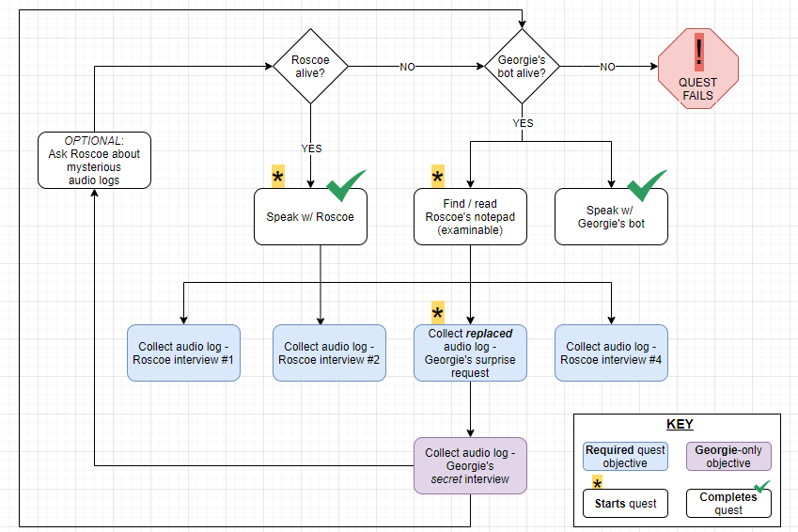

REACTIVITY / PLAYER CHOICE

* Deliver the logs to Roscoe or Georgie.
* Reveal Georgie’s deception to Roscoe.
* A non-required audio log of Georgie’s can be discovered near their old hangout spot, revealing Georgie’s reciprocal romantic interest for Roscoe and internal confliction.
* Additionally, Roscoe and/or Georgie’s bot can be killed. The quest will *only* fail if both are dead.

OBJECTIVE MAP

